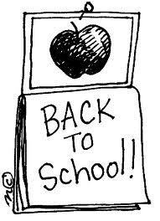
Schrader Elementary School
2nd Grade Supply List
2018-2019 School Year

Necessary Items:
2 black and white composition books
4 folders with pockets and prongs, 1 of each color: blue, green, red, and yellow.
1 pair of scissors
1 pencil box
1 backpack without wheels
1 package of 16 Crayola crayons
1 package of colored pencils
1 package of Dry Erase Markers
2 sets of ear buds or headphones
1 package of highlighters
1 Clipboard
1 package of wide ruled paper
2 boxes/packages sharpened pencils
1 package of Post-It Notes (3x3)
1 box of tissues
1 package of baby wipes (unscented)
1 box of zip-lock gallon bags
1 box of zip-lock sandwich bags
4 jumbo glue sticks or 8 small glue sticks

Wish List/Classroom Donation:
Index Cards (3x5)
Cardstock
Colored printer paper
Glitter
File folders

