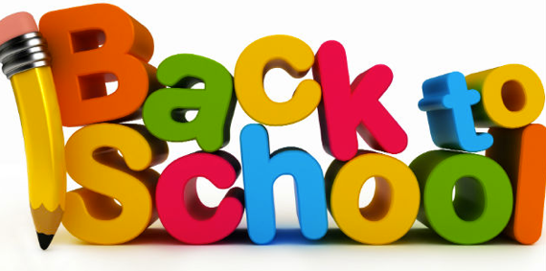
Schrader Elementary School
First Grade Supply List
2018-2019
Please DO NOT put your child’s name on the supplies

1 - backpack without wheels
1 - plastic pencil box
2 - plastic folders with prongs and pockets (red and blue only)
8 – jumbo glue sticks
24 – sharpened #2 pencils
2 – boxes of 24 count Crayola crayons
8 – black Expo markers
2 – black and white composition notebooks
1 – Fiskars scissors
2 – boxes of tissues
1 – Ziploc gallon size baggies (boys)
1 – Ziploc sandwich size baggies (girls)
1 – package of baby wipes
1 – bottle of hand sanitizer
1 – set of ear buds
1 – pack of pink bar erasers

Wish List:
-clorox wipes
-copy paper (white and colored)
-file folders
-extra glue sticks
-extra black expo markers
-Mr. Clean erasers
-treasure box items

