

Example: Ms. D: Miranda, do you agree or disagree with what Philipe said?

Miranda: Well, I sort of . . . like, I disagree?

Ms. D: Can you tell us why you disagree with what he said? What’s your reasoning?

Miranda: Because I thought that we said yesterday that you could divide even numbers by two. And I think you can divide twenty-four by two. And it’s twelve. So isn’t that even?

(Chapter 2: The Tools of Classroom Talk)

**Asking students to apply their own reasoning to someone else’s reasoning. (“Do you agree or disagree and why?”)**

**Agree or**

**Disagree**

**Disagree**

**Agree**



**Restate**

Example:

Ms. D: Can anyone repeat what Philipe just said in his or her own words? Miranda?

Miranda: Um, I think I can. I think he said that twenty-four is odd, because it can be divided by three.

Ms. D: Is that right, Philipe? Is that what you said? Philipe: Yes. (Chapter 2: The Tools of Classroom Talk)

Asking students to restate someone else’s reasoning.  (“Can you repeat what he just said in your own words?”)

Definition: To state again in a new way.

**Restate**

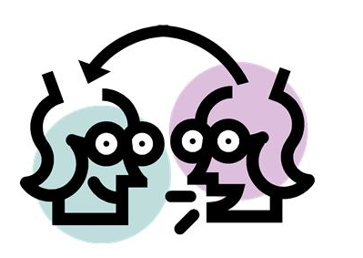

.

Example: Ms. D: So we have two different ideas here about the number twenty-four. Philipe, you’re saying that twenty-four is odd because you can divide it by three? Philipe: Uh-huh. Ms D: And Miranda, you’re saying that it’s even because you can divide it by two? Is that correct? Miranda: Yes. Ms. D: OK, so what about other people? Who would like to add to this discussion? Do you agree or disagree with Miranda’s or Philipe’s ideas? Tell us what you think, or add on other comments or insights.

This prompting for more input on previous statements will, over time, result in students showing more willingness to weigh in on what the group is considering.

**Add on**

Prompting students for further participation.  (“Would someone like to add on?”)

**Add on**

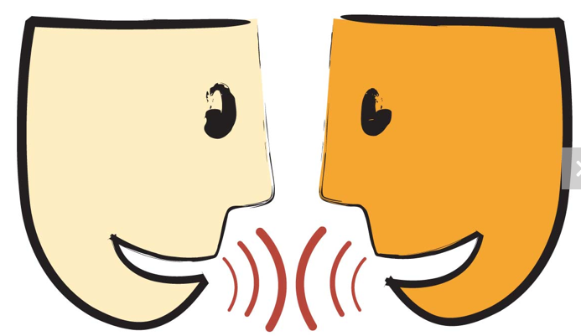

Philipe: Well, if we could use three, then it could go into that, but three is odd. So then if it was . . . but . . . three is even. I mean odd. So if it’s odd, then it’s not even.

Ms. D: OK, let me see if I understand. So you’re saying that twenty- four is an odd number?

Philipe: Yeah. Because three goes into it, because twenty-four divid-ed by three is eight.

**Revoice**

In a revoicing move, the teacher essentially tries to repeat some or all of what the student has said, and then asks the student to respond and verify whether or not the teacher’s revoicing is correct, as in the dialogue below.

*Definition:*

*To voice again.*

**Revoice**



By waiting to collect answers until most of the students have signaled with a quiet thumb that they are ready, you send the message that all students are expected to think and contribute during this time.

For your fast finishers, encourage students to place a second, third, or fourth finger up to indicate that they have two, three, or four ways to solve the problem.

The aim is not to reward speed, but to focus on thinking about mathematical relationships.

(Math Talks, Grades K-5 pg. 18)

**Wait Time**

**Using wait time. (“Take your time . . . we’ll wait . . .”).**

**Wait Time**