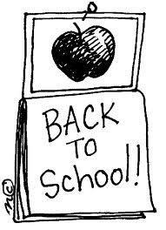
Schrader Elementary School
2nd Grade Supply List
2021-2022 School Year

Necessary Items:
2 packages of Black Dry Erase Markers
1 black and white composition book
4 folders with pockets and prongs- 1 of each color: blue, green, red, and yellow.
1 pair of scissors
1 pencil box
1 backpack without wheels
1 package of 24 Crayola crayons
1 set of ear buds or headphones
1 Clipboard
1 package of wide ruled paper
2 boxes/packages sharpened pencils
2 boxes of tissues
1 package of baby wipes (unscented)
1 box of zip-lock gallon bags
1 box of zip-lock sandwich bags
4 jumbo glue sticks

Wish List/Classroom Donation:
Cardstock
Colored printer paper

