Welcome to Pre-K!
21-22 school year

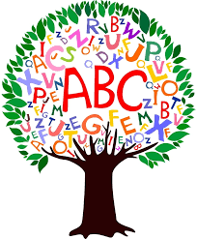
We are very excited to have your child in our classrooms this school year. Together we will focus on learning through hands-on exploration of the world around us while preparing for Kindergarten.

Please send in the following:

- A complete change of clothes labeled with child’s name in a zip lock bag, to remain in the classroom.
- Diapers, pull ups, baby wipes, special cup, if needed.
- 1 sharing size class snacks (gold fish, cheese balls, pretzels, gram crackers, fruit cups, etc.)
- 3-Kleenex tissues
- 2-Paper towels
- 2-Clorox wipes
- 2-packs dry erase markers
- 1-pack Jumbo crayons
- A blanket for rest time.
- Sleeping mat with student’s name on it
- An extra mask with your child’s name on it (if necessary)

