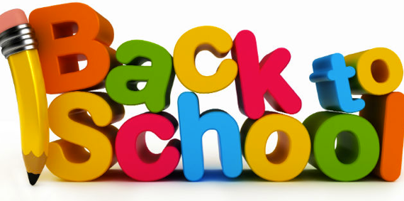
Schrader Elementary School
First Grade Supply List
2021-2022
Please DO NOT put your child’s name on the supplies

1 - backpack without wheels
1 - plastic pencil box
1 – 1 inch 3 ring binder
2 - plastic folders with prongs and pockets (red and blue)
2 – packages of jumbo glue sticks
2 – packages of sharpened #2 pencils
2 – boxes of 24 count Crayola crayons
2 – packages of black Expo markers
3 – black and white composition notebooks (no spiral notebooks please)
1 – Fiskars scissors
2 – boxes of tissues
1 – Ziploc gallon size baggies (freezer preferred) (boys)
1 – Ziploc sandwich size baggies (freezer preferred) (girls)
2 – packages of baby wipes
2 – bottles of hand sanitizer
1 – set of ear buds or head phones
2 – packs of pink bar erasers

Wish List:
-clorox wipes
-copy paper (white and colored)
-file folders
-extra glue sticks
-extra black expo markers
-Mr. Clean erasers
-treasure box items
-blank address labels

