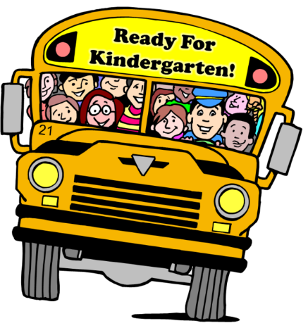
Kindergarten 2023-24 Supply List
Dear Families,
Welcome to Schrader! We are looking forward to getting to know you and your child! The first day of school begins on Thursday, August 10th at 9:10 A.M. and ends at 3:30 P.M. This is a general supply list that all kindergarten students will need. When you meet your child’s teacher in August, you may be asked for a few different items that each teacher requests from her students. The kindergarten teachers, in some cases, request “specific” brand names because they are high quality, last longer and from experience these supplies work the best.
The following supplies are requested by all the Kindergarten Teachers:

- 3 packs of Crayola Crayons (24 count)
- 1-inch white binder
- 12 large Crayola or Elmer’s glue sticks
- 3 pkg. (No. 2) pre-sharpened pencils
- 1 pair of Fiskars scissors
- 2 pack of 4 dry erase markers (Bullet tip preferred)
- 2 black and white composition notebooks (wide ruled)
- 1 large sized backpack (no wheels, please)
- 1 small plastic pencil box with lid (8 in. x 5 in. size, please)
- 1 box Kleenex tissues (200 count)
- 2 boxes of baby wipes
- 1 container of Lysol/disinfectant wipes
- 3 plastic 3 prong folder
- 2 fun folders of student’s choice
- 1 tray of Crayola Watercolor (washable) paint
- 1 large bottle of hand sanitizer
- 1 extra set of clothes (in case of accidents or spills) in a labeled Ziploc bag
- 1 box of gallon size Ziploc plastic bags- GIRLS ONLY
- 1 box of quart size Ziploc plastic bags- BOYS ONLY
- 1 over the head headphones (no earbuds please)
If it is possible to donate any of the items below, it would be greatly appreciated.
- 1 roll of toilet paper
- Markers
- Black Sharpies
- Colored Pencils
- Post-it Notes
- Play-doh
- Large (9 inch) and small (6inch) cheap PAPER plates (no plastic, Styrofoam, or Chinet)
- 1 box of 5 oz. paper cups
We are looking forward to meeting you in August!
Sincerely,
Kindergarten Teachers

