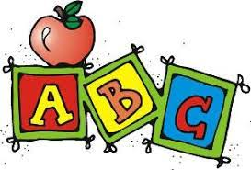
Pre-K Supply List 2023-24
- Mat for nap
- Small blanket for nap
- Pull-ups (if your child is not toilet trained)
- 3 Packages of baby wipes
- One extra set of clothes
- 2 Boxes of tissues
- 1 Packages of dry erase markers
- 1 Package of glue sticks
- 1 Box of colored pencils
- 2 Containers of disinfectant wipes

