Pre-K Supply List 2024-205

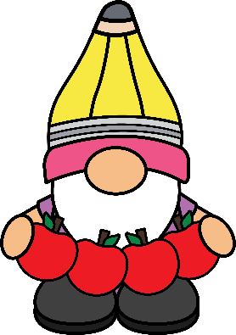

* Mat for nap
* Small blanket for nap
* Pull-ups (if your child is not toilet trained)
* 1 extra set of clothes
* 3 packages of baby wipes
* 2 boxes of tissues
* 1 package of dry erase markers
* 1 package of glue sticks
* 1 box of colored pencils
* 2 containers of disinfectant wipes